BOOTSTRAP ASSIGNMENT

1. What are the advantages of Bootstrap?

A saving time and effort by providing ready-made components and styles that can be customized and combined.

1. What is a Bootstrap Container, and how does it work?

A in Bootstrap, container is used to set the content's margins dealing with the responsive behaviors of your layout.

બુટસ્ટ્રેપમાં, કન્ટેનરનો ઉપયોગ તમારા લેઆઉટના પ્રતિભાવશીલ વર્તણૂકો સાથે કામ કરતી સામગ્રીના માર્જિનને સેટ કરવા માટે થાય છે

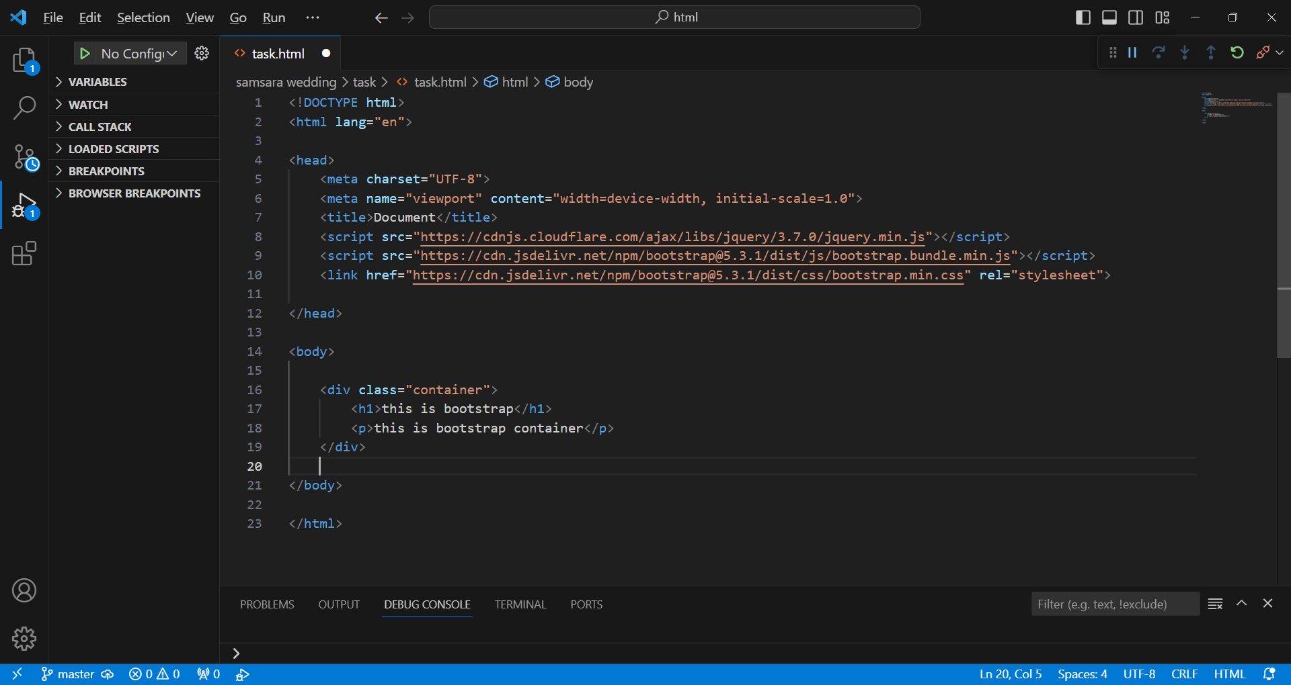

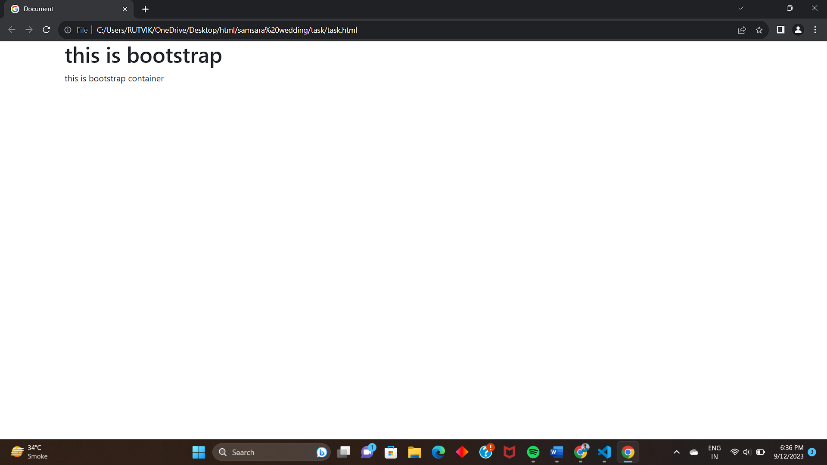

1. What are the default Bootstrap text settings?

A font size : 16px

line-height : 1.5

font-family : "Helvetica Neue", Helvetica, Arial, sans-serif.

1. What do you know about the Bootstrap Grid System?

A Bootstrap’s grid system uses a series of containers, rows, and columns to layout and align content.

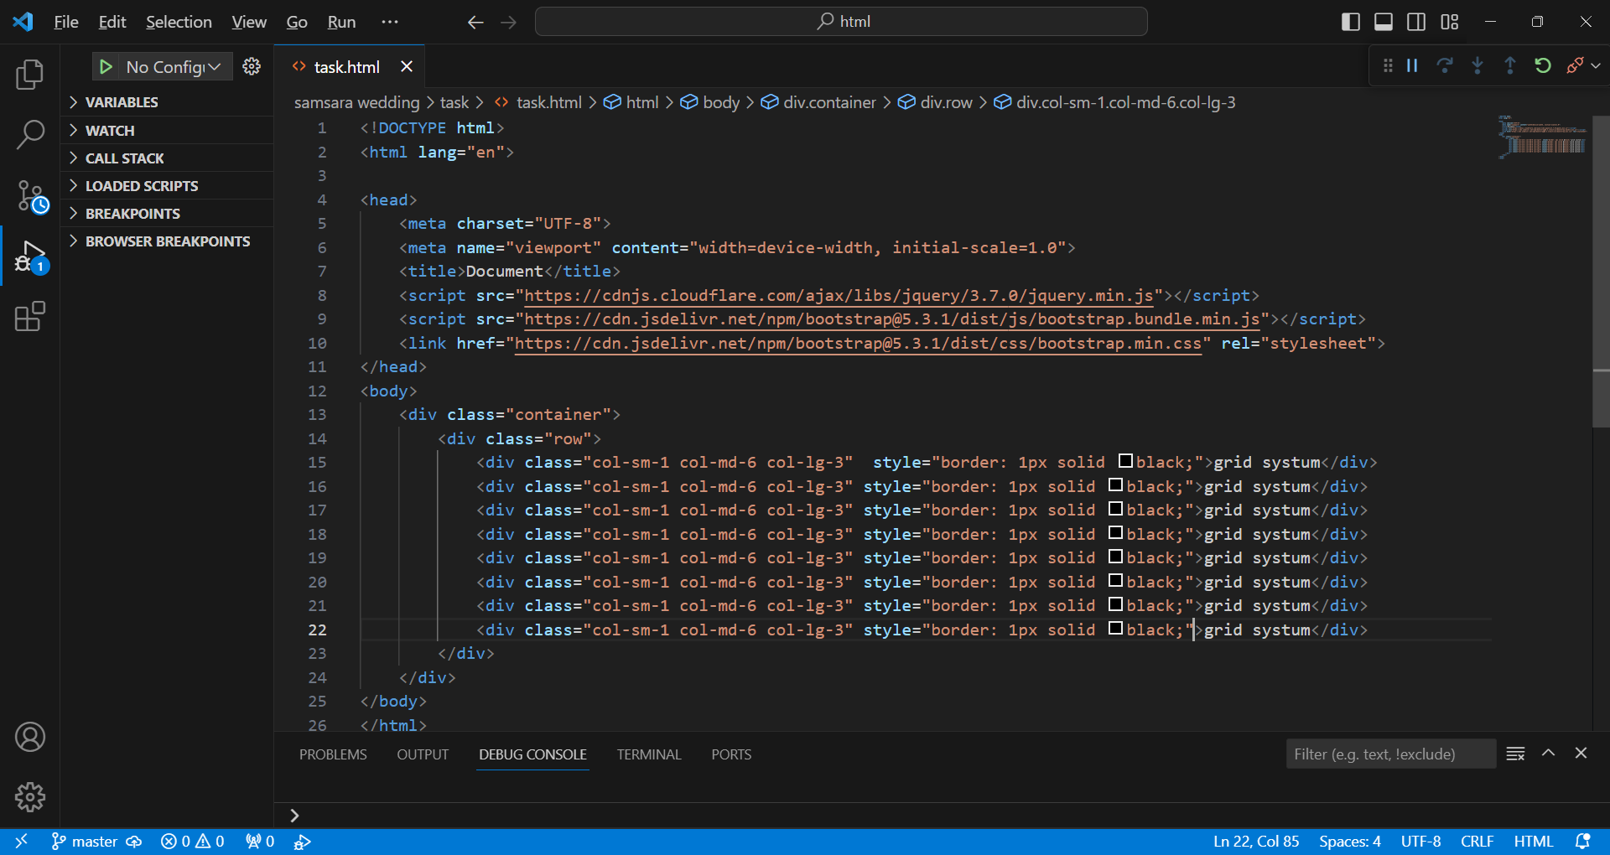

1. What is the difference between Bootstrap 4 and Bootstrap 5

A

* Bootstrap 4
* Grid – xs, sm, md, lg, xl
* limited colors
* supports IE(Internet Explorer) 10 and 11.
* It has jquery and all related plugins.
* Bootstrap 5
* Grid - xs, sm, md, lg, xl, xxl
* Extra colors added and various shades available
* Dosen’t supports IE(Internet Explorer) 10 and 11
* Jquery is removed and switched to vanilla JS

1. What is a Button Group, and what is the class for a basic Button Group?

A button group -Group a series of buttons together on a single line or stack them in a vertical column.

The class for a basic Button Group is “btn-group”.

1. How can you use Bootstrap to make thumbnails?

A

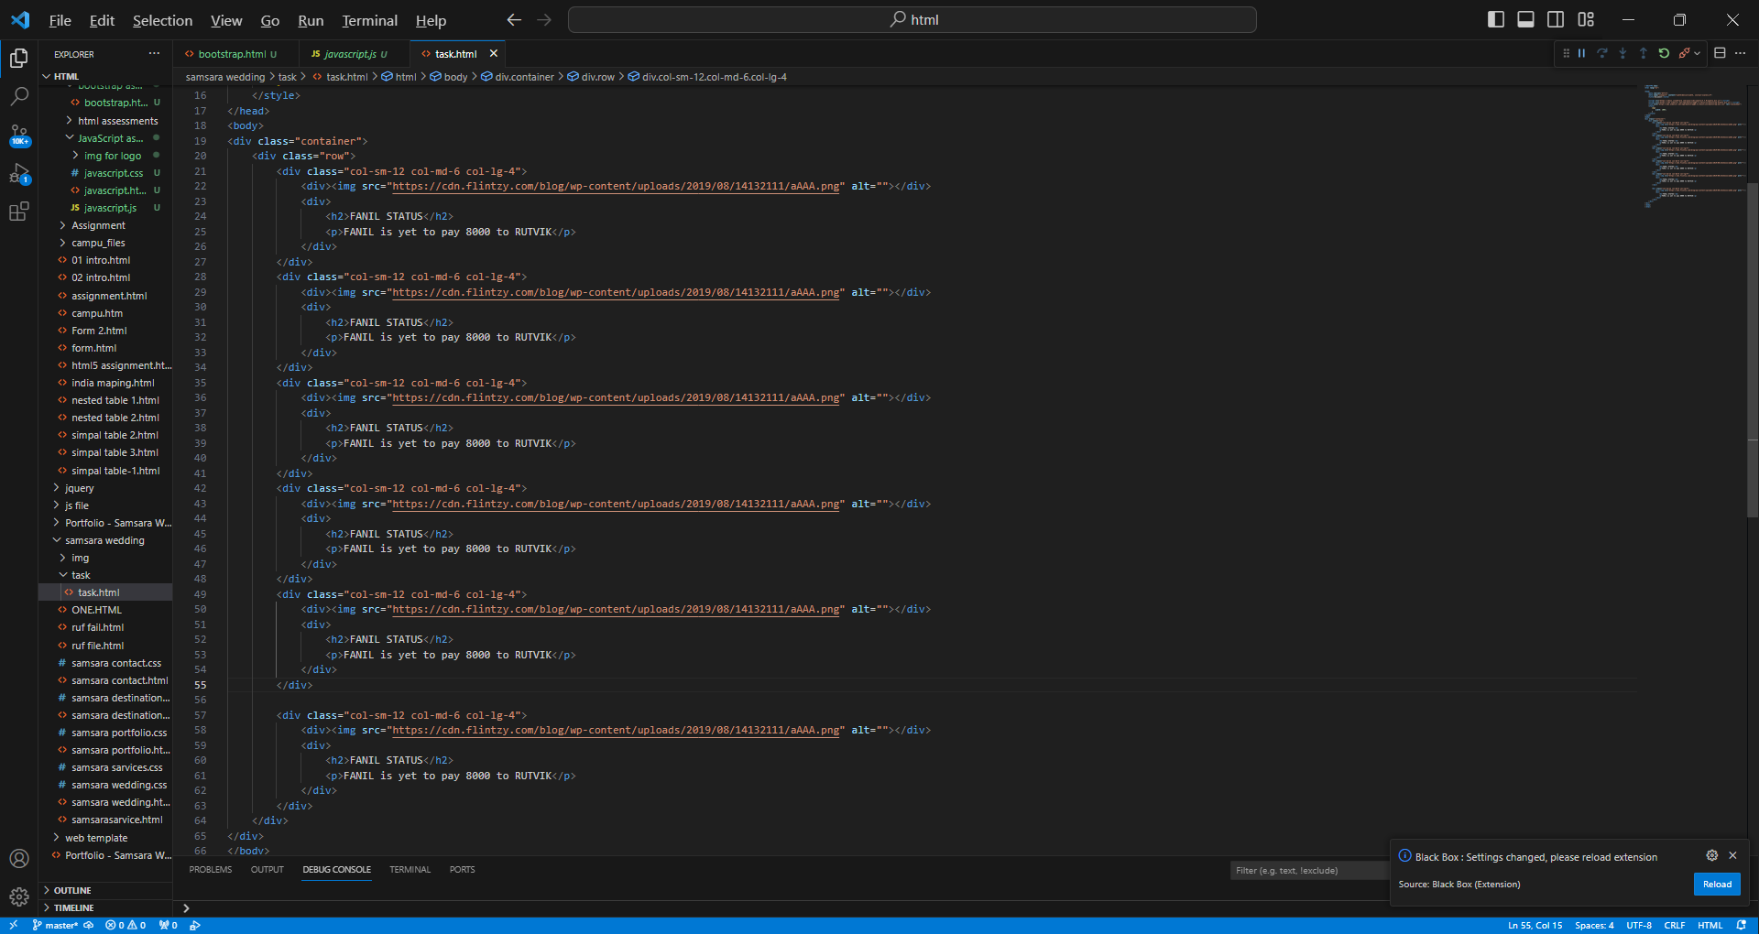

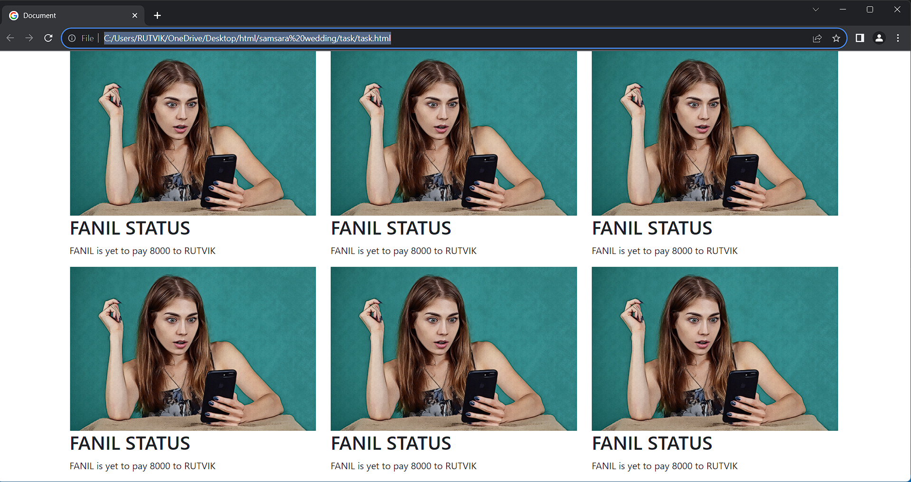

1. In Bootstrap 4, what is flexbox?

A Use flex classes to control the layout

The Flexible Box Layout Module, makes it easier to design flexible responsive layout structure without using float or positioning.

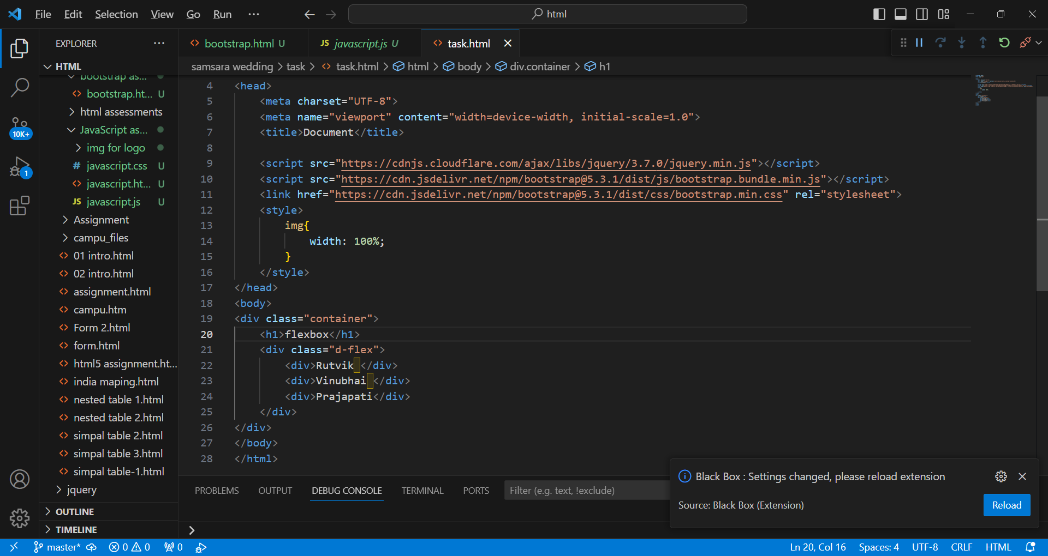

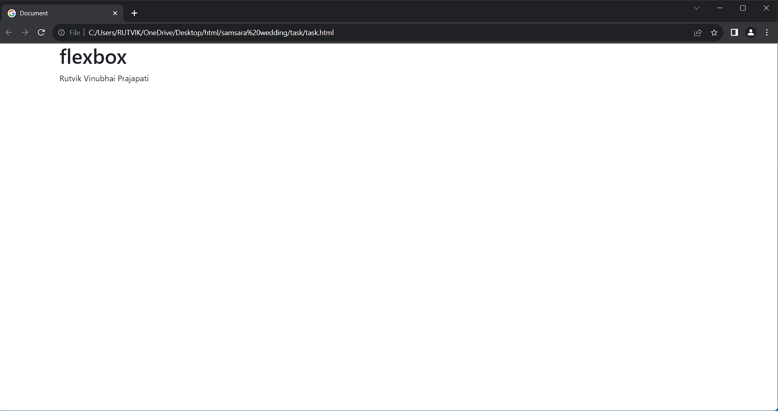

1. How can one create an alert in Bootstrap?

A 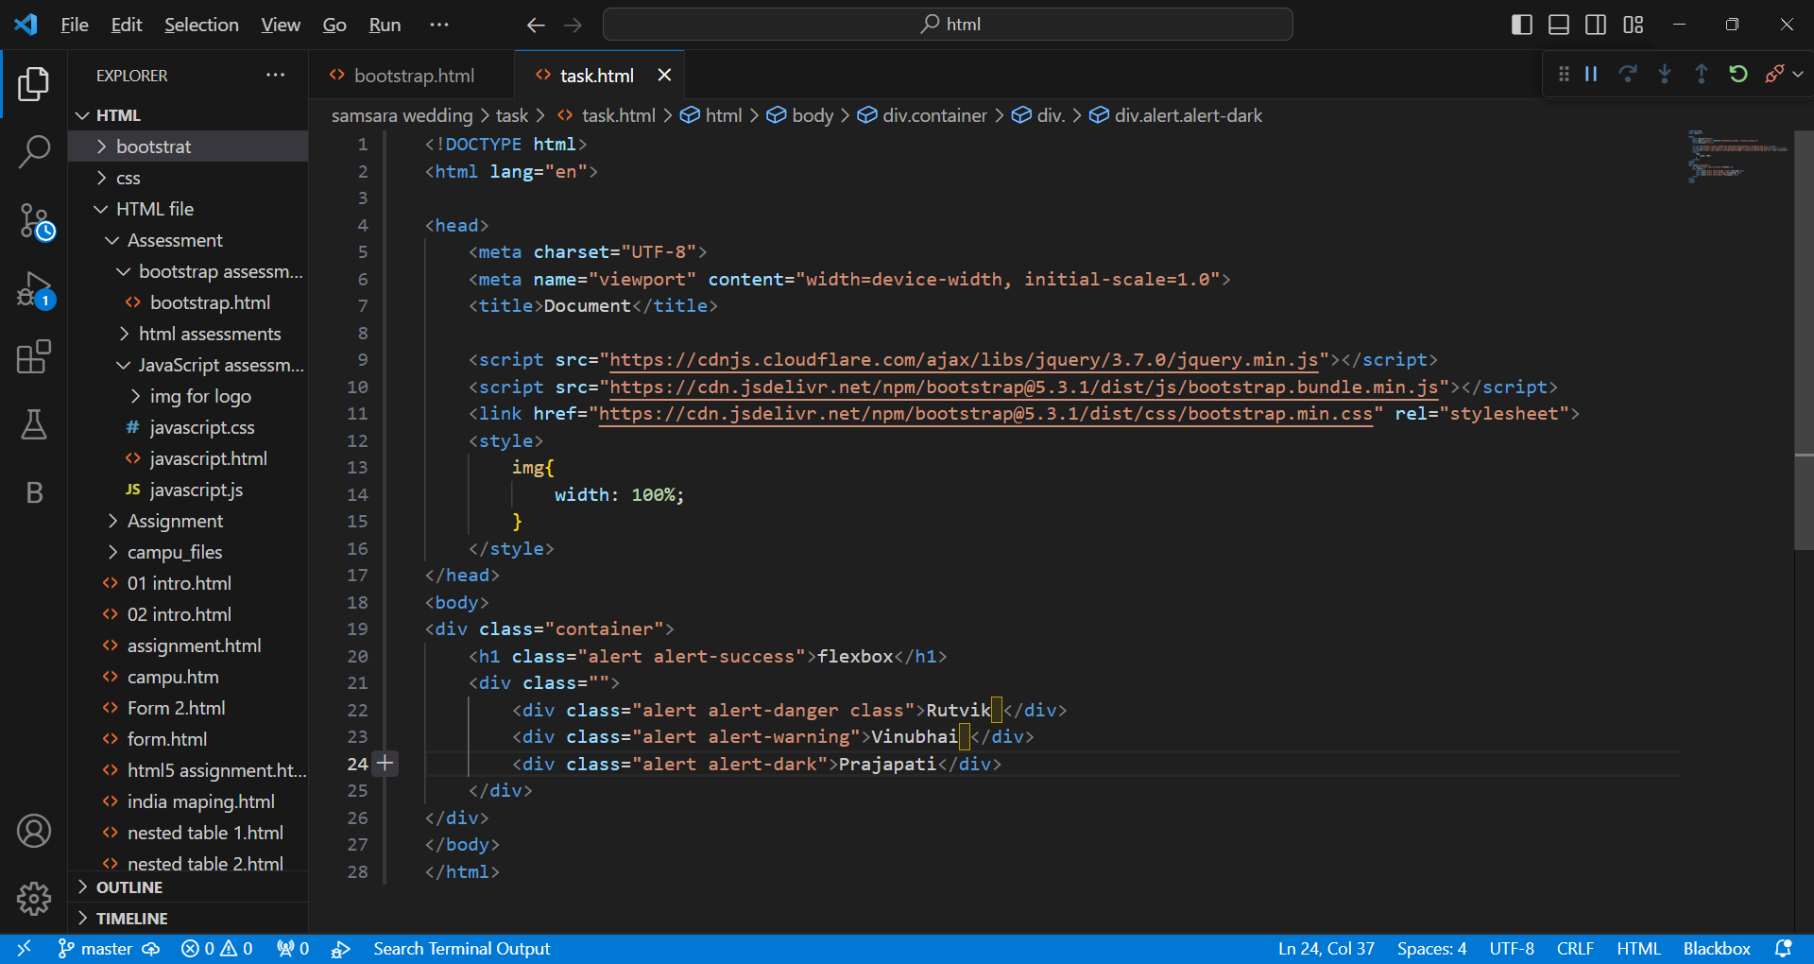

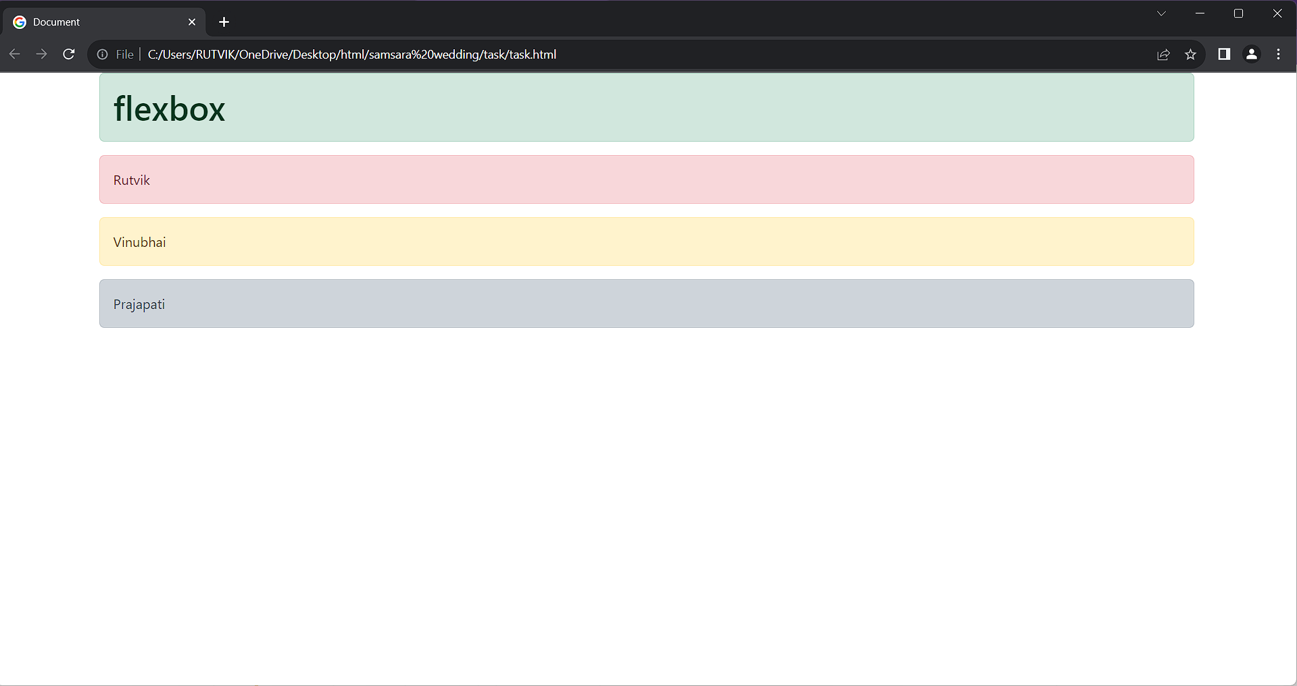

1. What is a bootstrap card and how would you create one?

